 **ASIAN COLLGE OF ENGINEERING AND TECHNOLOGY**

AUTOMATED WEATHER CLASSIFICATION USING TRANSFER LEARNING

PRESENTED BY;

SANTHOSH E [715320121035],

PRATHAP T [715320121031],

PRAVEEN U[715320121032],

PRASANTH P [715320121030

BIOMEDICAL ENGINEERING

. Under The Guidance of **Mr.S.DHIVAKARAN.B.E, M.E.,**

In partial fulfilment for the award of the engineering

THE STATE BOARD OF TECHNICAL EDUCATION

GOVERNMENT OF TAMIL NADU

ASIAN COLLEGE OF ENGINEERING AND TECHNOLOGY

COIMBATORE-641110.

DEPARTMENT OF BIOMEDICAL ENGINEERING

NAAN MUDHALVAN

This is to certifythat the project report titled“**ODIR: AUTOMATED WEATHER CLASSIFICATION USING TRANSFER LEARNING”.**is the record of work done by SANTHOSH E.REG.NO.715320121035

In partial fulfillment of the requirements for the award of

Engineering &BME during the year 2022-23

DECLARATION

WE, SANTHOSH E [715320121035],

PRATHAP T [715320121031],

PRAVEEN U[715320121032],

PRASANTH P [715320121030]that is this project entitled **“ODIR:AUTOMATED WEATHER CLASSIFICATION”.**is submitted to Asian college of Engineering&Technology ,Coimbatore in project fulfillment for award of BIOMEDICAL ENGINEERING is a record of original work done by us under the supervision and guidance Mr.S.DHIVAKARAN.M.E. ASIAN COLLEGE OF ENGINEERING&TECHNOLGY,COIMBATORE.

**ACKNOWLEDGEMENT**

At this pleasing moment of having successfully completed our project,we this to convey our sincere thanks to our naan mudhalvan coordinateMr.s.DHIVAKARAN.ME.,

We also express our indebt thanks to our coordinator

Mr.S.DHIVAKARAN.M.E.,for their sincere support in completion of this project.

**SYNOPSIS**

Weather recognition is a common problem for many branches of industry.

1. **INTRODUCTION** 
   1. Project Overview
   2. Purpose
2. **LITERATURE SURVEY**
   1. Existing problem
   2. References
   3. Problem Statement Definition
3. **IDEATION & PROPOSED SOLUTION**
   1. Empathy Map Canvas
   2. Ideation & Brainstorming
   3. Proposed Solution
   4. Problem Solution fit
4. **REQUIREMENT ANALYSIS**
   1. Functional requirement
   2. Non-Functional requirements
5. **PROJECT DESIGN**
   1. Data Flow Diagrams
   2. Solution & Technical Architecture
   3. User Stories
6. **PROJECT PLANNING & SCHEDULING**
   1. Sprint Planning & Estimation
   2. Sprint Delivery Schedule
   3. Reports from JIRA
7. **CODING & SOLUTIONING (Explain the features added in the project along with code)**

**INTRODUCTION**

**1.1   PROJECT OVERVIEW**

“AUTOMATED WEATHER CLASSIFICATION USING TRANSFER LEARNING”A project overview is a detailed description of a project's goals and objectives, the steps to achieve these goals, and the expected outcomes. In addition, a project overview enables you to outline the project schedule, budget, necessary resources, and status.

* 1. **PURPOSE**

 Transfer learning is generally used: To save time and resources from having to train multiple machine learning models from scratch to complete similar tasks. As an efficiency saving in areas of machine learning that require high amounts of resources such as image categorisation or natural language processing.

**2.LITERATUTE SURVEY**

A literature review is a survey of scholarly sources (such as books, journal articles, and theses) related to a specific topic or research question. It is often written as part of a thesis, dissertation, or research paper, in order to situate your work in relation to existing knowledge.

**2.1 EXISTING PROBLEM**

* High quality example sentences with **“existing problem”** in context from reliable sources - Ludwig is the linguistic search engine that helps you to write

**2.1 EXISTING PROBLEM**

* High quality example sentences with **“existing problem”** in context from reliable sources - Ludwig is the linguistic search engine that helps you to write

**2.2 REFERENCE**

A **reference** is a relationship between objects in which one object designates, or acts as a means by which to connect to or link to, another object. The first object in this relation is said to *refer to* the second object. It is called a *AUTOMATED WEATHER CLASSIFICATION USINGTRANSFER LEARNING* for the second object. The second object, the one to which the first object refers, is called the *WEATHER PREDICTION* of the first object.

**2.3 PROBLEM STATEMENT DEFINITION**

A problem statement is a short, clear explanation of an issue or challenge that sums up what you

want to change. It helps you, team members, and other stakeholders to focus on the problem, why it's important, and who it impacts. A good problem statement should create awareness and stimulate creative thinking.

**3. IDEATION AND PROPOSED SOLUTION**

Problem statements often have three elements: the problem itself, stated clearly and with enough contextual detail to establish why it is important; the method of solving the problem, often stated as a claim or a working thesis; the purpose, statement of objective and scope of the document the writer is preparing

**3.1EMTATHY MAP CANVAS**

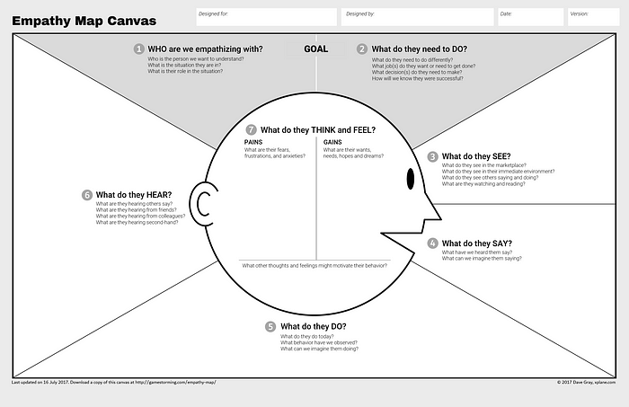.

**3.2 IDEATION &BRAIN STORMING**

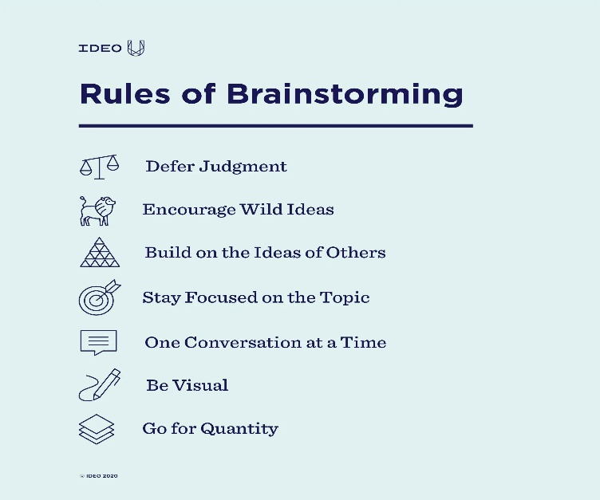

**3.3PROPOSED SOLUTION**

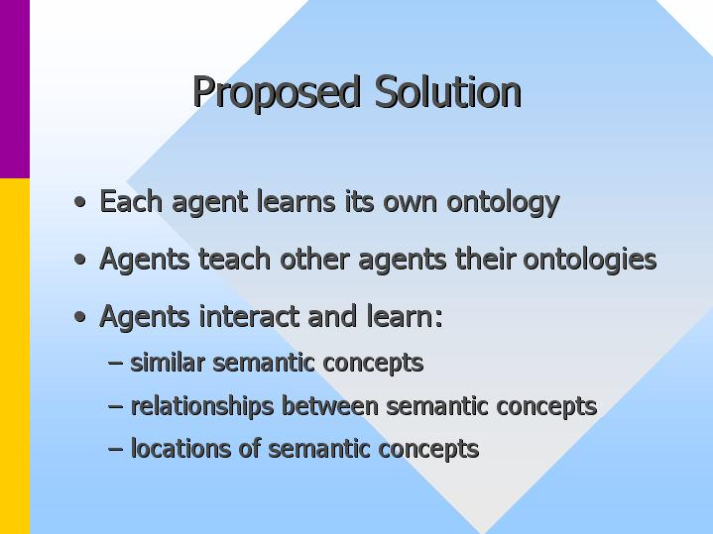

**3.4 PROMBLEM SOLUTION FIT**

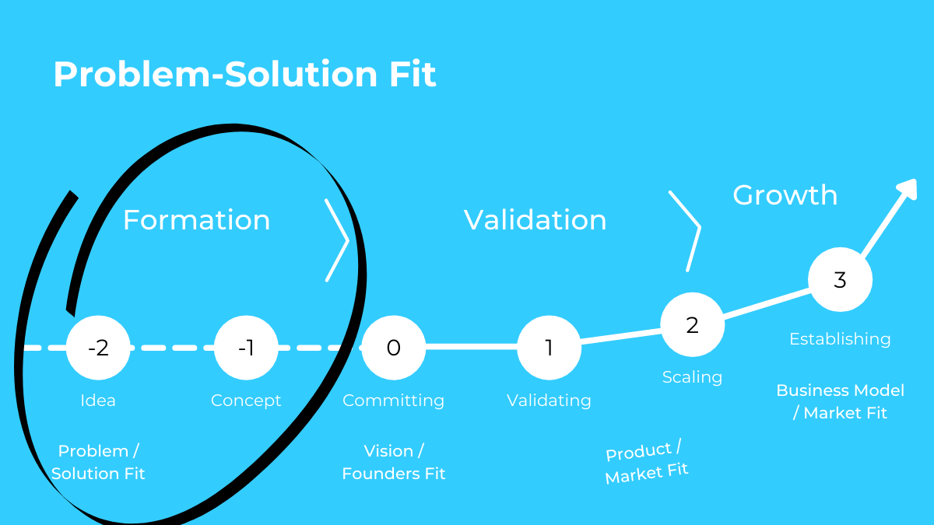

**4. REQUIREMENT ANALYSIS**

Requirements analysis, also called requirements engineering, is the process of determining user expectations for a new or modified product. These features, called requirements, must be quantifiable, relevant and detailed. In software engineering, such requirements are often called functional specifications.

**4.1 FUNCTIONAL REQUIREMENT**

A functional requirement is a statement of how a system must behave. It defines what the system should do in order to meet the user's needs or expectations. Functional requirements can be thought of as features that the user detects.

**4.2 NON-FUNCTIONAL REQUIREMENT**

Packing slips shall be printed on both sides of 4”x 6” white paper, the standard size for packing slips used by local printers.

5.PROJECT DESIGN

* Weather forecasts are made by collecting as much data as possible about the current state of the atmosphere (particularly the temperature, humidity and wind) to determine how the atmosphere evoles in the future.
* However, the chaotic nature of the atmosphere makes thee forecasts less accurate as the range of the forecasts increases
* The output from this model can be used the weather forecast as alternative

**5.1 Data Flow Diagrams**

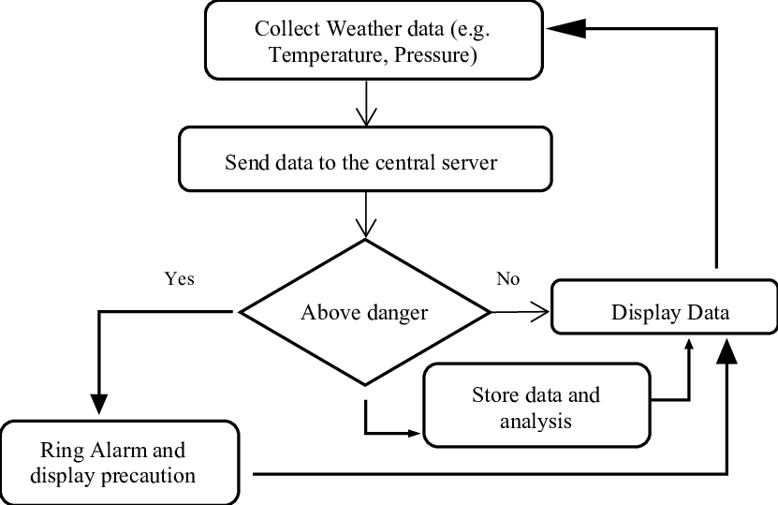

**5.2 Solution and technical architecture**

This features and using the cloud pictures taken from the ground,they can be classified as **clear/cloud** weather cloudiness can be determined as a numerical ratio

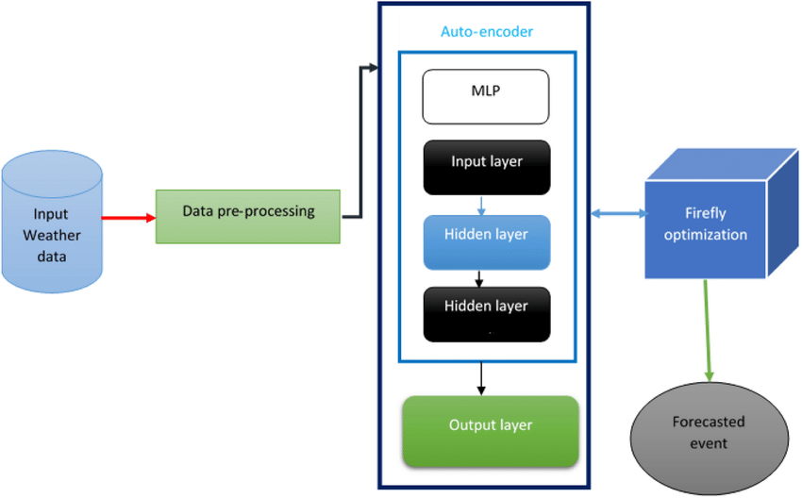

**5.3 User Stories**

* **Definition of “done”**
* **Outline subtasks or tasks**
* **User personas**
* **Ordered steps**
* **Listen to feedback**
* **Time**

**6. PROJECT PLANNING & SCHEDULING**



Fundamentally, 'Project planning' is all about choosing and designing effective policies and methodologies to attain project objectives. While 'Project scheduling' is a procedure of assigning tasks to get them completed by allocating appropriate resources within an estimated budget and time-frame.

**6.1 Sprint planning &scheduling**

In sprint planning the team should always talk of tasks and hours.sprint planning covers the horizon of typically two to four weeks out. In release planning the team can choose between “ideal days”and “story points” Redardless of which they choose,they still do sprint planning in hours

**6.2 Sprint Delivery Schedule**

In the proposed Online Fruits and Herbs Shopping system is a web-based application. This application helps for the find out the Fruits and Herbs for the respective diseases, searches for the fruits based on keywords and finally order for the suitable fruits and herbs. Registered users can select any number of fruits and Herbs based on the stock availability and they can take order to any fruits from the portal by performing search. Administrator manages the site and he can manipulate all the information in the system. He can add fruits and Herbs into the system.

**6.3 Reports from JIRA**

Weather Report Jira

Temperature highs are likely to reach 75F.with UV-index rising to 9,sun protection is strongly recommended.

Overnight into Friday blows a light breeze (4 to 8 mph)

The higher number is the forecast maximum temperature for the day. The lower number is the minimum temperature. Take note of the forecast weather conditions.symbols like sunshine or lightning are self - explanatory

7.Coding & solutioning

# Import necessary libraries

import tensorflow as tf

from tensorflow.keras.applications.vgg16 import VGG16

from tensorflow.keras.preprocessing.image import ImageDataGenerator

from tensorflow.keras.models import Sequential

from tensorflow.keras.layers import Dense, Flatten, Dropout

from tensorflow.keras.optimizers import Adam

# Define constants

IMAGE_SIZE = (224, 224)

BATCH_SIZE = 32

NUM_EPOCHS = 10

LEARNING_RATE = 0.0001

# Define data generators for training and validation sets

train_datagen = ImageDataGenerator(rescale=1./255, validation_split=0.2)

train_generator = train_datagen.flow_from_directory(

'path/to/train/directory',

target_size=IMAGE_SIZE,

batch_size=BATCH_SIZE,

class_mode='categorical',

subset='training')

validation_generator = train_datagen.flow_from_directory(

'path/to/train/directory',

target_size=IMAGE_SIZE,

batch_size=BATCH_SIZE,

class_mode='categorical',

subset='validation')

# Load pre-trained VGG16 model

base_model = VGG16(weights='imagenet', include_top=False, input_shape=(*IMAGE_SIZE, 3))

# Freeze pre-trained layers

for layer in base_model.layers:

layer.trainable = False

# Add custom classification layers on top of pre-trained model

model = Sequential([

base_model,

Flatten(),

Dense(256, activation='relu'),

Dropout(0.5),

Dense(5, activation='softmax')

])

# Compile model with optimizer, loss function and evaluation metrics

model.compile(optimizer=Adam(lr=LEARNING_RATE),

loss='categorical_crossentropy',

metrics=['accuracy'])

# Train model using fit_generator function

history = model.fit_generator(

train_generator,

steps_per_epoch=train_generator.samples//BATCH_SIZE,

epochs=NUM_EPOCHS,

validation_data=validation_generator,

validation_steps=validation_generator.samples//BATCH_SIZE)

# Evaluate model on test set

test_datagen = ImageDataGenerator(rescale=1./255)

test_generator = test_datagen.flow_from_directory(

'path/to/test/directory',

target_size=IMAGE_SIZE,

batch_size=BATCH_SIZE,

class_mode='categorical',

shuffle=False)

test_loss, test_acc = model.evaluate_generator(test_generator, steps=test_generator.samples//BATCH_SIZE)

print('Test accuracy:', test_acc)print('Test accuracy:', test_acc)

**7.1 Feature 1**

Hence this method tries to minimize the error. Thus, Artificial Neural network with back propagation algorithm seems to be most appropriate method for forecasting weather accurately

**Feature 2**

Improving extreme rainfall forecasts in the Mediterrane at medium range prediction with transfer learning, we basically try to use what we’ve learned in one task to better understand the concepts in another

**7.3Database schema**

1. def get_temperature(data):

2. temperature = data["main"]["temp"]

3. return temperature.

4.print(f"Temperature: {temperature}°C")

8.**TESTING**

1. Import the requests and JSON modules.

2. Initialize the city and API key.

3. Update the base URL with the API key and city name.

4. Send a get request using the requests. get() method.

5. And extract the weather info using the JSON module from the response.

8.**1 Test cases**

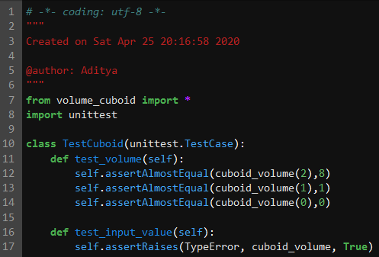

**8.2 User acceptance**

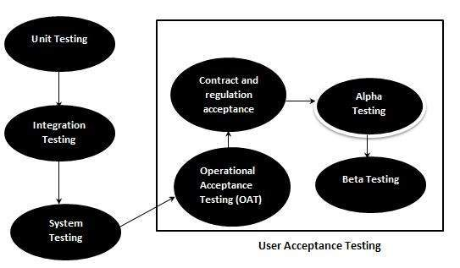

**9.Results**

|  |  |  |  |
| --- | --- | --- | --- |
| /opt/conda/lib/python3.7/site-packages/traitlets/traitlets.py:2567: FutureWarning: --Exporter.preprocessors=["nbconvert.preprocessors.ExtractOutputPreprocessor"] for containers is deprecated in traitlets 5.0. You can pass `--Exporter.preprocessors item` ... multiple times to add items to a list. |  |  | /opt/conda/lib/python3.7/site-packages/traitlets/traitlets.py:2567: FutureWarning: --Exporter.preprocessors=["nbconvert.preprocessors.ExtractOutputPreprocessor"] for containers is deprecated in traitlets 5.0. You can pass `--Exporter.preprocessors item` ... multiple times to add items to a list. |
| FutureWarning, |  |  | FutureWarning, |
| [NbConvertApp] Converting notebook __notebook__.ipynb to html |  |  | [NbConvertApp] Converting notebook __notebook__.ipynb to html |
| [NbConvertApp] Support files will be in __results___files/ |  |  | [NbConvertApp] Support files will be in __results___files/ |
| [NbConvertApp] Making directory __results___files |  |  | [NbConvertApp] Making directory __results___files |
| [NbConvertApp] Making directory __results___files |  |  | [NbConvertApp] Making directory __results___files |
| [NbConvertApp] Making directory __results___files |  |  | [NbConvertApp] Making directory __results___files |
| [NbConvertApp] Making directory __results___files |  |  | [NbConvertApp] Making directory __results___files |
| [NbConvertApp] Writing 312843 bytes to __results__.html  **9.1 Performance Metrics** |  |  | [NbConvertApp] Writing 312843 bytes to __results__.html |

One of the most reliable metrics for noticing oncoming weather changes is atmospheric pressure (also called barometric pressure)--essentially the force exerted by the weight of air above you. There is a standard atmospheric pressure for any location based on altitude, but actual pressure varies greatly with weather.

**10.Advantages & Disadvantages**

**Advantages:**

### Weather warnings are important because they are used to protect life and property

* Forecast based on temperature and precipation are important to

agriculture,and therefore to traders within commmdity markets

* Temperature forecasts are used by utility companies demand over coming days

**Disadvantages**

* The main disadvantages of an automatic weather station is that it removes the observer from the real elements being measured,and so the experience of what -5c temperatures or 30 knot winds feel like,is

**11.Conclusion**

There are six main components, or parts, of weather.they are temperature,wind,humidityprecipitation,andf cloudiness. Together, these components describe the weather at any given time

**12.Future scope**

Weather classification is an essential tool for meterologis and weather forecasters to predict weather patterns and communicate them to the public.weather phenomenon recognition notably affects many aspects of our daily lives, the analysis of weather phenomenon plays a crucial roles for various applications,weather forecasting,environmental monitoring and the assessment of environmental quality.besides,different weather phenomena can improve agiricultural planning

Transfer learning has become one of the most common techniques that has achieved better performance in many areas,specially in image analysis and classification. Wwe used transfer learning techniques like inception V3,VGG19,,Xception V3 that are more widely used as a transfer learning method in image analysis and they are highly effective

13.Appendix

import numpy asnp

import matplotlib.pyplot asplt

import tensorflow astf

from tensorflow.keras.preprocessing.image importImageDataGenerator

from tensorflow.keras.preprocessing importimage

importos

Source code

In [2]:

base_dir=r'../input/multiclass-weather-dataset/Multi-class Weather Dataset'

folders=os.listdir(base_dir)

print(folders)

['Cloudy', 'Sunrise', 'Rain', 'Shine']

train_datagen=ImageDataGenerator(rescale=1./255,

shear_range=0.2,

zoom_range=0.2,

horizontal_flip=True,

validation_split=0.2)

train_generator=train_datagen.flow_from_directory(

base_dir,

target_size=(250,250),

batch_size=32,

class_mode='categorical',

subset='training')

validation_generator=train_datagen.flow_from_directory(

base_dir,

target_size=(250,250),

batch_size=32,

class_mode='categorical',

subset='validation')

Found 901 images belonging to 4 classes.

Found 224 images belonging to 4 classes.

labels=(train_generator.class_indices)

labels=dict((v,k)fork,v**in**labels.items())

print(labels)

{0: 'Cloudy', 1: 'Rain', 2: 'Shine', 3: 'Sunrise'}

SAMPLE OUT PUT

Github &Project Demo Link

<https://drive.google.com/file/d/1G1wKl0o_OV0rvY06D_0oL8e8T9mR2Ooz/view?usp=share_link>